REPUBLIC OF CAMEROON
Peace-Work-Fatherland
MINISTRY OF HIGHER EDUCATION
INSTITUT UNIVERSITAIRE DE LA COTE
REPUBLIQUE DU CAMEROUN
Paix-Travail-Patrie
MINISTAIRE DE LENSEIGNEMENT SECONDAIRE
INSTITUT UNIVERSITAIRE DE LA COTE




INTERNSHIP REPORT
IMPLEMENTATION OF A FIRE DETECTION SYSTEM

Bootcamp done on the 17th April 2023 in partial fulfilment of the B.Tech
(Bachelor of Technology)

Field of study: Computer Sciences and Engineering

Written and presented by: Ebongue Nsame Elie Maxwell

Under the supervision of:
Mr. TATSOPTEU ENDELLY & MR. WEMBE FOUTHE
ACADEMIC YEAR 2023-2024

CERTIFICATION

This document is to certify that Bootcamp with the theme: “IMPLEMENTATION OF A FIRE DETECTION SYSTEM”: case of A SCHOOL or parallel Industry, is originally written and presented by EBONGUE NSAME ELIE MAXWELL after a two month of preparation carried out at IUC to meet up with the partial the requirement and regulation governing the award of Bachelor of Technology (B.Tech) at the Institut Universitaire de la Cote in the field Computer Sciences and Engineering.

DEDICATION

TO MY FAMILY

AKNOWLEDGEMENT

The accomplishment of this work required the assistances of some people. Failing to quote them individually here, they receive my most sincere thanks. I Am particularly grateful to:
- Mr. GUIMEZAP Paul, Founder and President of IUC for the establishment of this structure for the purpose of training students.
- Mm. POUYAP MERIELLE, my Academic supervisor, who has been a of great help in the accomplishment of this work me.
- Mr. TENGA EMILE, my professional supervisor for having given me his attention throughout this period of internship, for his support, his trust, his availability, his advices and his precious remarks.
- Mr. DEFFO ROMEO, for granting me an internship in his company.
- ALL MY TEACHERS for the knowledge they instilled in me.
- All my FRIENDS AND CLASSMATES who contributed in one way or the other to the realization of my project.
To anyone I have failed to mention here, thank you.

ABSTRACT

The Fire Detection System is a project aimed at providing an efficient and reliable solution for detecting fire or smoke hazards. By utilizing various sensors and output devices, the system is capable of promptly detecting the presence of fire or smoke and providing visual and audible alerts to users. The system is built around an Arduino Uno microcontroller board, which monitors the inputs from a smoke sensor and controls an LCD screen, LEDs, and a buzzer. When the smoke sensor detects smoke above a certain level, the system triggers the alarm by activating the buzzer and the red LED. The LCD screen displays relevant information, including system status. The green LED indicates normal operating conditions. The Fire Detection System offers an affordable and accessible solution for enhancing safety measures and preventing potential disasters caused by fire or smoke hazards. Future enhancements may include incorporating additional sensors and implementing wireless communication for remote monitoring. The project showcases the practical application of Arduino microcontrollers in developing effective fire detection systems. Not having a breadboard shouldn't prevent you from working on the project. You can still connect the components using jumper wires and connect them directly to the Arduino board. Here's a general guide on how to connect the components without a breadboard:

PREFACE

With the aim of ensuring a suitable development and providing business with competent and competitive workforce in various fields, the Cameroonian government through the ministry of higher education has opened the private institution of education. This then created the
HIGHER INSTITUTE OF TECHNOLOGY AND INDUSTRIAL DESIGN (ISTDI) by decree
No 02/0094/MINESUP/DDES/ESUP of September 13 2002 and authorization of opening No
0102/MINESUP/DDES/ESUP of 18 September 2002, located in the coastal region, Wouri
department, district of Douala 5th, in Logbessou district. The ISTDI the created the
UNIVERSITY INSTITUTE OF THE COAST by decree No
5/05156/N/MINESUP/DDES/ESUP/SAC/EBM. Giving the opportunity to private Institutions
to contribute to the acquisition of academic and professional training in appropriateness with
the professional World.
University Institute of the Coast (IUC) consist of five (5) different Institutions which are:
SCHOOL OF ENGINEERING AND APPLIED SCIENCES (SEAS)
❖ HND INDUSTRIAL PROGRAMS
➢ Electrical power systems (EPS)
➢ Industrial Computing and Automation (ICA)
➢ Telecommunication (TEL)
➢ Software Engineering (SWE)
➢ Networks and security (NWS)
➢ Chemical Manufacturing (CM)
➢ Mechanical Manufacturing (MEM)
➢ Building Science and Technology (BST)
❖ HND COMMERCIAL PROGRAMS
➢ Marketing (MKT)
➢ Management (MGT)
➢ Accountancy (ACC)
➢ Banking and Finance (BF)
➢ Logistics and transport management (LTM)
❖ BACHELORS OF ENGINEERING (BEng)
➢ Computer Science Engineering o
➢ Electromechanical Engineering o
➢ Civil and Environmental Engineering
❖ BACHELORS OF TECHNOLOGY (BTech)
➢ Chemical Engineering
➢ Electrical and Electronics Engineering
➢ Civil Engineering
➢ Software Engineering
➢ Mechatronics Engineering
➢ Industrial automation and computing
➢ Welding and Fabrication Technology
➢ Thermal Engineering Technology
❖ BACHELORS OF HEALTH SCIENCE (B-HES)
➢ Physiotherapy
➢ Medical Laboratory
➢ Nursing science
L’INSTITUT SUPÉRIEUR DES TECHNOLOGIES ET DU DESIGN INDUSTRIEL
(ISTDI)
❖ BTS PROGRAMS:
➢ Génie Chimique des procédés (GCP)
➢ Maintenance des systèmes informatique (MSI)
➢ Informatique Industriel (II)
➢ Electrotechnique (ET)
➢ Electronique (EN)
➢ Froid et climatisation (FC)
➢ Maintenance et après-vente automobile (MAVA)
➢ Bâtiment (BAT)
➢ Travaux publics (TP)
➢ Géomètre topographe (GT)
➢ Energie Renouvelable (ER)
➢ Génie Bois (GB)
➢ Chaudronnerie (CH)
➢ Fabrication Mécanique (FM)
❖ DSEP PROGRAM:
➢ Réseaux et Télécommunication (RT)
❖ LICENCES PROFESSIONNELLES INDUSTRIELLES in partnership with the
University of DSCHANG:
➢ Administration des systems Réseaux
➢ Génie Logiciel
➢ Automatique et informatique Industrielle
➢ Electrotechnique
➢ Electronique
➢ Management des systèmes Automobiles
➢ Maintenance et Expertise des Automobiles
➢ Maintenance des systèmes Industriels
➢ Génie Energétique et Industriel
➢ Production et commercialisation du bois
➢ Ameublement et construction du bois
➢ Génie Mécanique et productique
❖ MASTER PROFESSIONNEL INDUSTRIEL in partnership with the University of
DSCHANG
➢ Génie Electrique et informatique Industrielle
➢ Génie des Réseaux et Télécommunications
➢ Systèmes d’information et Génie Logiciel
➢ Systèmes d’information Audit et Conseil
❖ LIPRO
➢ Génie Civil
❖ MPRO
➢ Génie Civil
L’INSTITUT DE COMMERCE ET D’INGÉNIERIE D’AFFAIRES (ICIA)
❖ BTS PROGRAMS
➢ Action Commerciale
➢ Assurance
➢ Banque et Finance
➢ Communication d’Entreprise
➢ Commerce International
➢ Gestion Logistique et Transport
➢ Informatique de Gestion
❖ LICENCES PROFESSIONNELLES COMMERCIALES ET GESTION in partnership
with the University of DSCHANG:
➢ Assurance
➢ Banque
➢ Banque – Assurance
➢ Comptabilité Contrôle et Audit
➢ Finance – Comptabilité
➢ Gestion des Ressources Humaines
➢ Logistique et Transport
➢ Marketing
➢ Management des Opérations du Commerce International
❖ MASTER PROFESSIONNEL COMMERCIAL in partnership with the University of
DSCHANG
➢ Finance-Comptabilité
➢ Audit Comptable et Financier
➢ Banque
➢ Fiscalité
➢ Management des Organisation
➢ Marketing-Communication
➢ Gestion des Ressources Humaines
➢ Logistique et Stratégique
❖ MASTER ISUGA-FRANCE in partnership with EMBA France
❖ EXECUTIVE MBA in partnership with ESSEC Douala
L’INSTITUT D’INGÉNIERIE INFORMATIQUE D’AFRIQUE CENTRALE (3IAC)
❖ Cycle des TIC in partnership with CCNBDIEPPE of CANADA
➢ Réseautique et sécurité
➢ Programmes et Analyse
❖ MASTER EUROPEAN in partnership with 3IL France
➢ Genie Logiciel
➢ Administration des Systèmes Réseaux
❖ MASTER PROFESSIONNEL in partnership with ENSP Yaoundé
➢ Génie Civil
➢ Génie Energétique et Environnement
➢ Génie Industriel et Maintenance
❖ CYCLE INGENIEUR Information (3IL-France)
➢ Pôle de Recherche Innovation et Entreprenariat
LES PROGRAMMES INTERNATIONAUX DES SCIENCES ET TECHNOLOGIES DE
L’INNOVATION (PISTI)
❖ Cycle des Classes Préparatoires aux Grandes Ecoles d’Ingénieurs (CP) in partnership
with the University of MAINE FRNACE:
➢ Classes préparatoires
➢ Licences Sciences et techniques
❖ CYCLE INGENIEUR de Génie Industriel (Polytechnique-NANCY France)
❖ INGENIEURIE BIOMEDICALE in partnership with the University of Tor Vergara
(ROME II)
❖ ARCHITECTURE ET DESIGN INDUSTRIEL in partnership with the University of
CAMERINO (ROME

LIST OF ACRONYMS

HND: Higher National Diploma
IoT: Internet of Things
LAN: Local Area Network
NIC: Network Interface Card
S1: Switch 1
R2: Router 2
ISP: Internet Service Provider
SSID: Service Set Identifier
DNS: Domain Name System

TABLE OF CONTENTS

Contents
CERTIFICATION…………………………………………………………………….……………………..i
DEDICATION………………………………………………………………………………………………ii
AKNOWLEDGEMENTS……………………………………………………………………….………………………………………………iii
ABSTRACT…………………………………………………………………………….……………………………………………………………..iv
PREFACE……………………………………………………………………………………………………..……………………………………….vi
IDENTIFICATION SLIP………………………………………………………….…………………………………………………………….xii
LIST OF ACCRONYMS………………………………………………………………………………………………………………………xiii
TABLE OF CONTENT…………………………………………………………………………………………………………….…………..xiv

GENERAL INTRODUCTION

The Fire Detection System project is aimed at developing an efficient and reliable solution for detecting fire or smoke hazards. Fire incidents pose significant risks to human lives, property, and the environment. Therefore, having a robust fire detection system in place is crucial to enhance safety measures, minimize potential risks, and enable timely response and evacuation.

The project utilizes various sensors and output devices integrated with an Arduino Uno microcontroller board to monitor the environment, process data, and provide visual and audible alerts when fire or smoke is detected. By combining hardware components and programming, the Fire Detection System aims to provide an effective early warning system for potential fire hazards.

The system incorporates a smoke sensor as the primary input device. The smoke sensor detects the presence of smoke particles in the air and provides an analog output signal that is processed by the Arduino Uno. When the smoke level exceeds a certain threshold, the system triggers visual alerts, such as LEDs, and audible alerts, such as a buzzer, to promptly notify individuals in the vicinity.

The project focuses on creating an affordable and accessible solution by utilizing cost-effective components and open-source technology. This approach makes the Fire Detection System suitable for various applications, including residential buildings, offices, industrial sites, and public spaces.

Furthermore, the Fire Detection System project offers opportunities for learning and skill development. It encourages individuals to explore the practical application of microcontrollers, sensors, and output devices, fostering technical knowledge and innovation in the field of fire safety technology.

In conclusion, the Fire Detection System project addresses the critical need for early detection of fire or smoke hazards. By utilizing sensors, microcontrollers, and output devices, the system aims to enhance safety measures, minimize risks, and provide timely alerts for prompt response and evacuation. The project’s affordability, accessibility, and educational aspects make it a valuable contribution to fire safety awareness and prevention.

1. JUSTIFICATION OF TOPIC
Introduction :
The Fire Detection System project aims to develop a system capable of detecting fire or smoke hazards and providing timely alerts to mitigate potential risks. This justification outlines the importance and relevance of the project in enhancing safety measures and preventing fire-related disasters. The Fire Detection System project is justified by the need to enhance safety measures, provide early detection of fire or smoke hazards, and minimize the potential risks associated with fire incidents. The project’s cost-effectiveness, accessibility, and educational aspects make it a valuable endeavor in promoting fire safety awareness and prevention. By implementing the Fire Detection System, we aim to contribute to the well-being of individuals, protection of property, and the overall safety of communities.

Safety Enhancement
Fire incidents pose significant risks to human lives, property, and the environment. By implementing a Fire Detection System, the project aims to enhance safety measures by providing early detection and timely response to fire or smoke hazards. This proactive approach can minimize the potential for injuries, fatalities, and property damage.

- Rapid Alert and Response :
The Fire Detection System utilizes sensors to promptly detect fire or smoke. Once a hazard is detected, the system triggers visual and audible alerts, such as LEDs and a buzzer, to notify individuals in the vicinity. These immediate alerts enable quick response and evacuation, potentially saving lives and reducing the intensity and spread of fires.

- Cost-Effective Solution :
The project focuses on utilizing an Arduino Uno microcontroller board and affordable components, making the Fire Detection System a cost-effective solution compared to commercial fire detection systems. This aspect is particularly beneficial for small businesses, residential settings, and low-resource environments where access to advanced fire detection systems may be limited.

- Accessibility and Customizability :
The Fire Detection System project emphasizes the use of readily available components and open-source technology, making it accessible to a wide range of users. The system can be customized and expanded based on specific requirements, allowing for flexibility in implementation across diverse applications, including homes, offices, industrial sites, and public spaces.

- Educational and Skill Development :
Developing the Fire Detection System provides an opportunity for learning and skill development in areas such as electronics, programming, and system integration. The project encourages individuals to explore the practical application of microcontrollers, sensors, and output devices, fostering technical knowledge and innovation.

- Future Potential and Expansion :
The Fire Detection System serves as a foundation for future enhancements and advancements in fire safety technology. It can be integrated with additional sensors, such as gas detectors, to enhance the system’s capabilities. Moreover, the project can serve as a platform for the development of interconnected fire detection systems, enabling centralized monitoring and remote notifications.

CHAPTER TWO: DIAGNOSTIC OF EXISTING SYSTEM

In section one we shall describe the topic and present the existing system. In section two see how to install the hardware used for fire detection system.

DESCRIPTION OF THE EXISTING SYSTEM
Our environments are mostly sensitive to fire which increases their risk of fire damages, most schools, offices, cars do not have a fire detection system and we often see people noticing fire at an advanced rate which can no more be controlled.

RESEARCH METHODS
While carrying out my research, I used the following methods,
- INTERVIEW: I asked the administration and personnel of various workplaces and how all the devices are interconnected which was currently active and its extents and point it can reach or leads to short-circuit.

ADVANTAGES AND LIMITATIONS OF THE PRESENT SYSTEM
ADVANTAGES
- As personnel are on their work space they can detect a simple particle of smoke in the surrounding.
- Cable management is correctly done since very few is needed.
- Sending alarming sounds
- The presence of a socket helps the system to continue working, if a generator is present the system would never go off.

LIMITATIONS
- Scalability: This system have a problem of detection of long distances, smoke coming over a distance of 6M would be difficult or rather impossible to be detected if the threshold is not attained.
- Temperature sensor capable of comparing temperature of the surrounding.
- Camera devices of easy detection and monitoring of the workplaces.
- An alternative power supply like a battery in case of current leakage.

CHARACTERISTICS OF A FIRE DETECTION SYSTEM IN AN OFFICE
- It can enhance security by the implementation of security measures through various devices and sensors which facilitates the communication and fire alarms which when real-time monitored ensures a safe environment of the office.
- The system understand and assimilates the intensity of various gases or smoke to send the alarms only and only if the threshold is attained, however if the intensity of gas or fire decreases unexpectedly the alarm stops automatically.

3.1.7 BENEFITS OF IMPLEMENTING A FIRE DETECTION SYSTEM IN A SCHOOL
- Saves time: Easy the reading of values due to a screen and LEDs.
- Improves security: Since it would rapidly detect fire
- Adaptability: Student can easily see read, rapidly figure out signals.

3.2 Technical Notebook of the new system

3.2.1 INTRODUCTION
The Technical Notebook provides detailed documentation of the Fire Detection System, including hardware components, software implementation, and system integration. It serves as a comprehensive guide for understanding the technical aspects of the project.
It enables monitoring, and efficiency improvements in safety. Common applications include smart homes, offering real-time insights, automation, and improved for better decision-making.

3.2.2 IMPLEMENTING A HOME WITH FIRE DETECTION

REQUIREMENTS
To reproduce the system and implement, we will use a simulation tool. The simulation tool we will use is :
Arduino version 2.3.2,
Arduino board
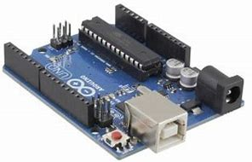
Smoke sensor
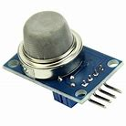
LEDs
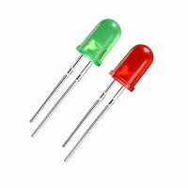
IC2 LCD Screen,
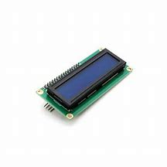
Buzzer.
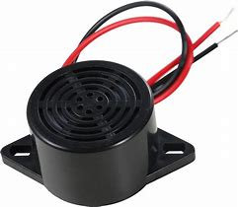

3.2.3 DOWNLOADING AND INSTALLING Arduino IDE 2.3.2 (64 BITS)
- MINIMUM SYTEM REQUIREMENT FOR Arduino IDE 2.3.2 (64 BITS)
    - Microsoft Windows 8.1, 10, 11 (64bit), Ubuntu 20.04 LTS (64bit) or macOS 10.14 or newer.
    - amd64(x86-64) CPU
    - 4GB of free RAM
    - GB of free disk space

Step 1: Downloading Arduino IDE 2.3.2
- Go on any of your browser and type “download Arduino Ide.
- Then you click on the first proposition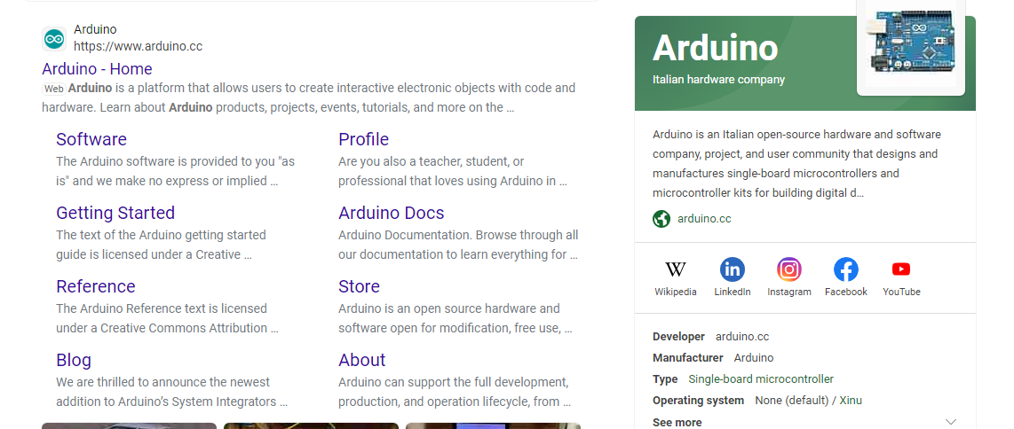

Figure 2: Selecting the first link to download Arduino ide 2.3.2
- Then you click on the “download” button

Figure 3: Clicking on the " just Download " button to download Packet Tracer

Step 2: Installing Arduino Ide 2.3.2
- You click in download folder to see the software you have downloaded
- In the download folder you will open the program folder
Figure 4: opening the Program folder to find the Arduino ide we have downloaded

- You then open program to see the software you have downloaded

Figure 5: Double clicking on the software to install
- Then you double click on the software to begin the installation and you select “I accept the agreement
Figure 6: Installing the software
- Then you click on the “Next” button
- Now the installation of software is over click on “Finish” button to launch the software
- The software is ready for simulation

CHAPTER FOUR: IMPLEMENTATION OF FIRE DETECTION SYSTEM

This chapter is divided into two sections. In section one, we shall see how we carried out the simulation. In section two, we shall talk about the strength, limitations and weakness of the system, Section three talks about the general conclusion and the references.

4.1.1 CONFIGURING THE NEW SYSTEM

Devices required and their use:
- Arduino Uno: The main microcontroller board responsible for data processing and controlling the system.
- Smoke Sensor: Detects the presence of smoke and provides an analog output.
- Buzzer: Produces an audible alarm when fire or smoke is detected.
- LEDs: Indicate the system status through visual alerts.
- LCD Screen (I2C): Displays relevant information and alerts.

4.1.2 REPRESENTATION OF THE CODE WITH ARDUINO IDE

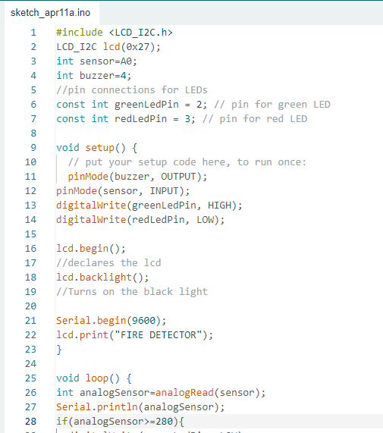
Fig 8: C code of the system
Figure above shows a piece of code of the system

4.1.3 VERIFYING THE CODE
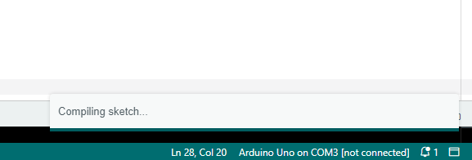
Fig 9: Debuging the code

4.1.4 UPLOADING THE CODE
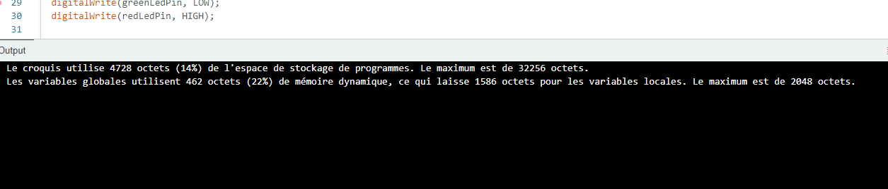

4.1.6AUTOMATING ACTIONS OF DEVICES
We have automated some actions such as alarming so that when each time there is smoke in a hall immediately an alarm is sent, also if the smoke diffuses in air the alarm automatically stops.
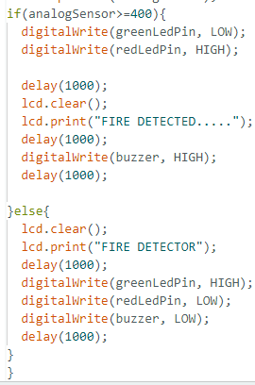
Fig 5: Automating actions between sensors and LEDs
1. Hardware Setup:
- Connect the Arduino Uno to the computer using a USB cable for programming and power supply.
- Connect the smoke sensor to the analog input pin of the Arduino Uno.
- Connect the buzzer and LEDs to the digital output pins of the Arduino Uno.
- Connect the LCD screen to the Arduino Uno using the I2C interface.

2. Software Implementation:
- Install the Arduino IDE (Integrated Development Environment) on the computer.
- Write the firmware code for the Arduino Uno, which includes:
- Initializing the pins for the smoke sensor, buzzer, LEDs, and LCD screen.
- Implementing the logic for smoke detection and triggering the appropriate alerts.
- Displaying relevant information on the LCD screen.
- Upload the firmware code to the Arduino Uno using the Arduino IDE.

3. System Workflow:
- Initialization:
- The Arduino Uno initializes the pins and components.
- The LCD screen displays the system name and status.

- Monitoring:
- The smoke sensor continuously detects the presence of smoke and provides an analog output.

- Fire Detection:
- If the smoke level exceeds a predefined threshold, the Arduino Uno triggers the buzzer to emit an alarm sound.
- The appropriate LEDs are activated to indicate the detection of fire or smoke.

- User Feedback:
- The LCD screen displays relevant information, including system status and alerts.

4. Testing and Calibration:
- Conduct thorough testing to ensure the proper functioning of the system.
- Calibrate the smoke sensor to adjust the threshold for smoke detection
4.1.7AUTOMATING ACTIONS OF DEVICES
1. LCD Connections:
- Connect the VCC pin of the LCD to the 5V pin on the Arduino.
- Connect the GND pin of the LCD to the GND pin on the Arduino.
- Connect the SDA pin of the LCD to the SDA pin (A4) on the Arduino.
- Connect the SCL pin of the LCD to the SCL pin (A5) on the Arduino.

2. LED Connections:
- Connect the anode (longer leg) of the green LED to the digital pin 2 on the Arduino.
- Connect the anode (longer leg) of the red LED to the digital pin 3 on the Arduino.
- Connect the cathode (shorter leg) of both LEDs to the GND pin on the Arduino.

3. Temperature Sensor Connections:
- Connect the VCC pin of the temperature sensor to the 5V pin on the Arduino.
- Connect the GND pin of the temperature sensor to the GND pin on the Arduino.
- Connect the data pin (middle pin) of the temperature sensor to the analog pin A0 on the Arduino.

4. Buzzer Connection:
- Connect the positive pin of the buzzer to the digital pin 4 on the Arduino.
- Connect the negative pin of the buzzer to the GND pin on the Arduino.

5. Smoke Sensor Connection:
- Connect the VCC pin of the smoke sensor to the 5V pin on the Arduino.
- Connect the GND pin of the smoke sensor to the GND pin on the Arduino.
- Connect the analog pin of the smoke sensor to the analog pin A1 on the Arduino.

Make sure to double-check the pin connections and adjust them as needed according to your specific components and Arduino board. Once the connections are made, you can upload the code to the Arduino and test the project.

4.2 STRENGTH AND LIMITATIONS OF THE NETWORK
STRENGTHS:
- Some devices can be programmed to work automatically without any human interaction in response to needs of the company detected by sensors.
- Regular monitoring of the performance of the system data transmission and security helps detect issues early and prevent miss-interpretation.
- Environmental monitoring: Environmental factors such as temperature, humidity can be monitored to create a comfortable and healthy learning condition for students and staff.
LIMITATIONS:
- Incorporate additional sensors, such as gas sensors, to enhance the system's capabilities.
- Compatibility issues: devices may need some specific connections which are very fragile.

4.2.2WEAKNESSES OF THE SYSTEM
- A loss or degradation in connectivity is likely to affect the efficiency of the system. Such a loss can have dramatic effects.
- A leakage of electricity can lead to a powering off of the system which can have serious effects if fire is in.
- They require maintenance and constant updates to ensure optimal performance.

REMARKS
POSITIVE REMARKS
- Since it’s a new technology everyone was exited in the idea of implementing it which was a good source of motivation for everyone.
- Punctuality was highly respected.
- There was collaboration amongst each other.
- We had a good quality connection
NEGATIVE REMARKS
- Lack of some Working materials.
- Sometimes closing time was not considered.
- Mostly some material got damages due to mis interpretation of the pins.

CONCLUSION

The aim of this project was to implement the Fire Detection System, we aim to enhance safety measures and provide early detection of fire or smoke, enabling timely response and prevention of potential disasters in a school environment to improve the security of the school premises, optimize resource utilization and at the same time provide comfort and a healthy environment to the school staff and students. Security was improved. Resources were optimized by the use of sensors like smoke sensors which controls the buzzer in response to change in aeration hence prevent the overuse of power by the device. All these were designed and simulated in Arduino ide and worked correctly.

REFERENCES

[1] "A Survey on Internet of Things: Architecture, Enabling Technologies, Security and Privacy, and Applications" by Jayavardhana Gubbi, Rajkumar Buyya, Slaven Marusic, and Marimuthu Palaniswami in IEEE Access.

[2] "Internet of Things: A Review of Surveys Based on Context Aware Intelligent Services" by C. Perera, A. Zaslavsky, P. Christen, and D. Georgakopoulos in IEEE Communications Surveys & Tutorials.

[3] "Internet of Things (IoT): A Vision, Architectural Elements, and Future Directions" by R. Roman, J. Lopez, and M. Mambo in Future Generation Computer Systems.

[4] "A Comprehensive Survey on Internet of Things: Security and Privacy Issues" by S. Sicari, A. Rizzardi, L. A. Grieco, and A. Coen-Porisini in IEEE Communications Surveys & Tutorials.

[5] "A Survey of Internet-of-Things: Future Vision, Architecture, Challenges and Services" by S. Al-Fuqaha, M. Guizani, M. Mohammadi, M. Aledhari, and M. Ayyash in IEEE Internet of Things Journal

